3rd Grade Supply List
2019-2020 School Year
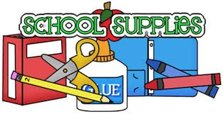
Necessary Items:
- 16 – 24 Count Box of Crayons
- 1 pair of children’s Scissors
- 2 glue sticks
- 1 Highlighter of each color – yellow, pink, green
- Wooden Pencils (No designs)
- 2 Expo dry erase markers
- A sock (or small cloth) to use as an eraser for their slates
- 2 pencil erasers
- One BLUE pen – to use a checking tool

Optional Items:
- 10 count box of broad line markers
- Colored pencils

SCIENCE: Black and white composition book

Kleenex donations are welcome! ☺

